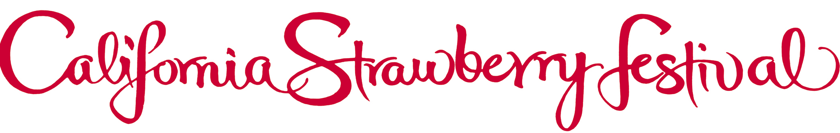

FOR IMMEDIATE RELEASE:
Contact: Lisa Carey PR (818) 889-1085 or lisa@lisacareypr.com

2014 CALIFORNIA STRAWBERRY FESTIVAL MAY 17, 18

OFFERS SPECIAL DISCOUNTS TO GROUPS THAT INCLUDE FREE TICKETS

The more, the merrier is also more economical when groups get together to enjoy special discounts on tickets to the 31st Annual California Strawberry Festival celebration May 17, 18, 2014 at Strawberry Meadows of College Park in Oxnard.

Groups of 20 or more who order tickets before April 30 already receive a $1 discount and two free tickets, and now until March 21st, any group of 30 or more will receive an additional two free tickets along with their discount (total 4 free tickets). Information and downloadable forms are available at www.strawberry-fest.org under the tab “Getting There.”

Jam-packed with fun for all ages, the Festival boasts strawberries every way imaginable, with concert performances, more than 200 Fine Arts & Crafts booths, the Strawberry Promenade with celebrity cooking demonstrations, Strawberryland For Kids featuring rides and attractions, gooey contests, special appearances, and more, all on 15 scenic acres of parkland.

Oxnard is located just 60 miles north of Los Angeles and 30 miles south of Santa Barbara. The free Park & Ride “Strawberry Express” shuttles from six convenient locations off the 101 Fwy make getting to the Festival a breeze with direct access. Amtrak California is offering a special Kids Ride Free promotion festival weekend (shuttles meet the trains). Parking is also available on site for $10.

General admission is $12, seniors 62+ are $8 and children ages 5-12 are $5. Kids 4 and under are free. Active military and dependents with ID are $8. Hours are 10:00a.m. to 6:30p.m. Tickets can be purchased in advance at www.strawberry-fest.org. The California Strawberry Festival information line is 1 888 288-9242.
Use our convenient Mobile app: Text “berry” to 95577.

